Portal for Academia–Industry Collaboration for Skill Mapping, Internships & Placement

1. Project Overview
The proposed system is a centralized web platform that connects students, colleges, departments, companies, internship providers, placement recruiters, and skill-development organizations.
The main objective is to create a single platform where:
- Students maintain their academic and skill profiles.
- Colleges manage students, departments, internships, placements and industry interactions.
- Companies publish internship and job opportunities.
- Companies can specify required skills, qualifications and eligibility criteria.
- The system automatically evaluates students against these requirements.
- Eligible students receive suitable internship/job recommendations.
- Companies can discover students based on their skills.
- Skill gaps can be identified and students can be directed toward relevant skill-enhancement programs.
- College administrators can monitor internship and placement activities through dashboards.

2. High-Level System Architecture
The system should be designed as a role-based multi-tenant platform.
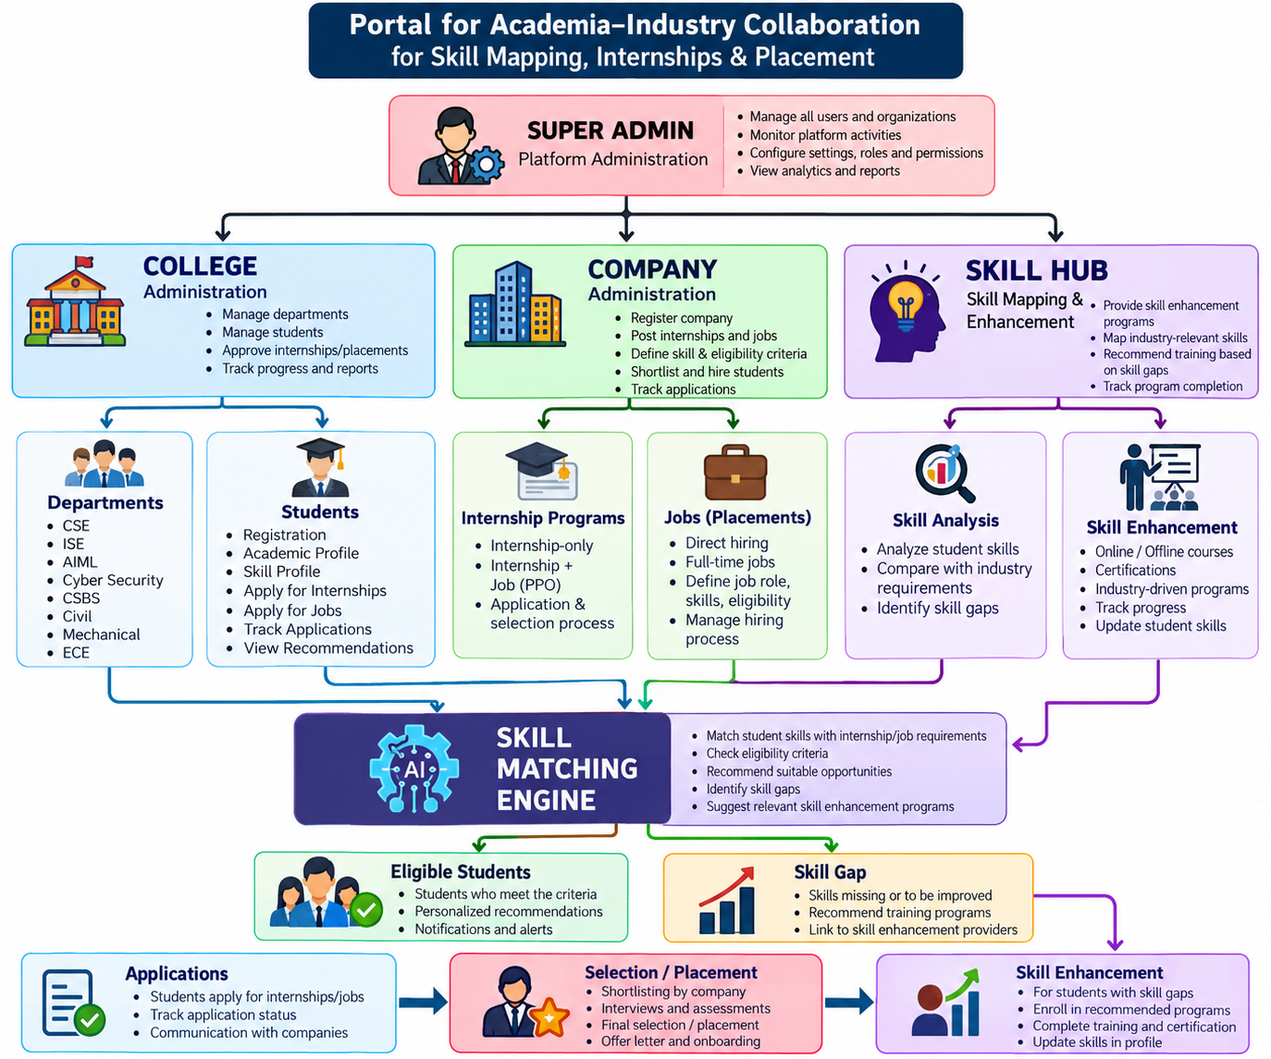

3. Main User Types
The platform should have a clear role and permission structure.
Role | Main Responsibility
Super Admin | Complete platform administration
Platform Admin | Manage users, companies, colleges and configurations
College Admin | Manage college-level activities
Department Admin / HOD | Manage department students and opportunities
Faculty / Placement Coordinator | Manage internships, placements and student progress
Student | Profile, skills, applications and opportunities
Company Admin | Company profile and recruitment
Company Recruiter | Manage internships/jobs and candidates
Skill Provider | Publish training/skill programs
Mentor | Guide students and track progress
Not every installation needs every role initially. The system should be designed so additional roles can be added later.

4. Authentication & User Management Module
This should be one of the first modules developed because every other module depends on authentication and authorization.

Features
- User registration
- Login
- Logout
- Forgot password
- Reset password
- Email/mobile verification
- Role-based login
- Account activation/deactivation
- Password change
- Profile management
- Session management
- Role-based access control
- Permission management
- Login history
- Account status
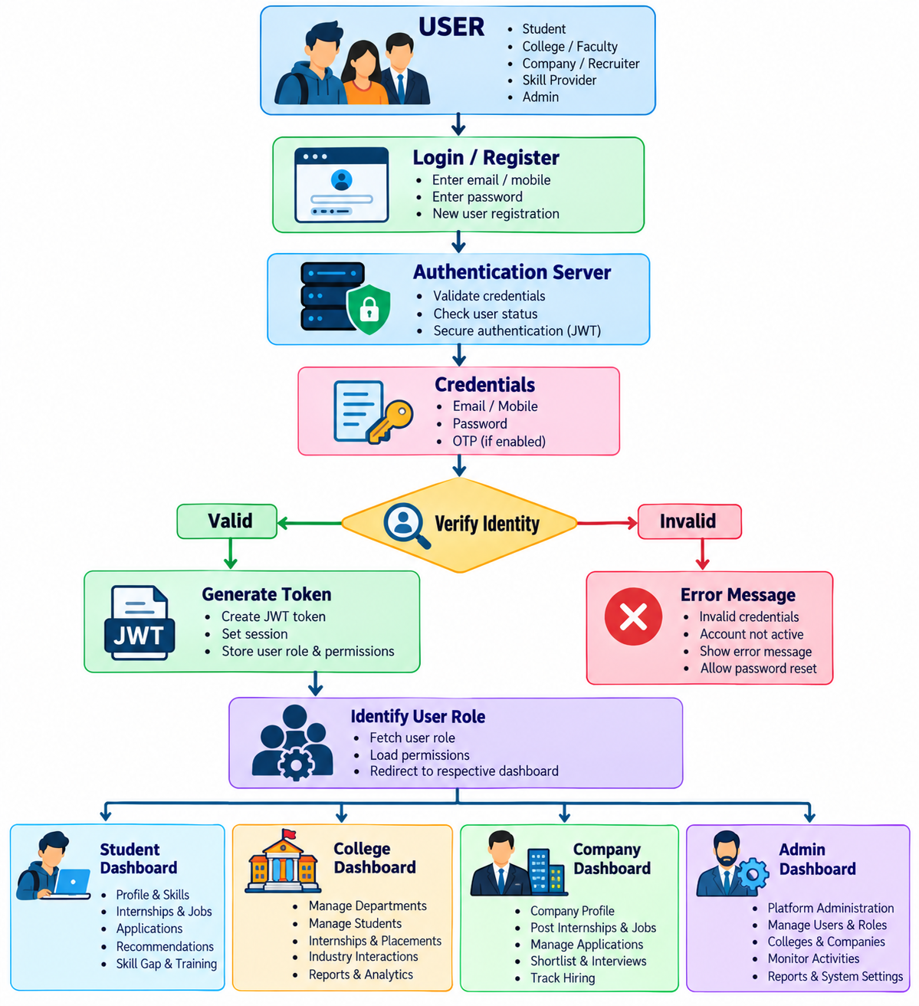For the backend, the development team can use JWT-based authentication with refresh-token/session handling.

5. Super Admin Module
The Super Admin has complete control over the platform.

Dashboard
Display:
- Total colleges
- Total departments
- Total students
- Active students
- Total companies
- Internship opportunities
- Job opportunities
- Applications
- Selected students
- Placement percentage
- Internship conversion rate
- Skill gaps
- Skill enhancement programs
- Active recruiters

Management
Super Admin can manage:
- Colleges
- Departments
- Users
- Students
- Companies
- Recruiters
- Skill providers
- Skills
- Job categories
- Internship categories
- Academic programs
- Locations
- Roles
- Permissions
- System configurations

Administrative Actions
- Approve/reject college registration
- Approve/reject company registration
- Suspend accounts
- Activate/deactivate opportunities
- Manage platform notifications
- View audit logs
- Generate reports

6. College Management Module
A college can register and maintain its institutional profile.

College Profile
Information such as:
- College name
- College code
- University
- Accreditation information
- Address
- Website
- Contact details
- Principal
- Placement officer
- Departments
- Academic programs
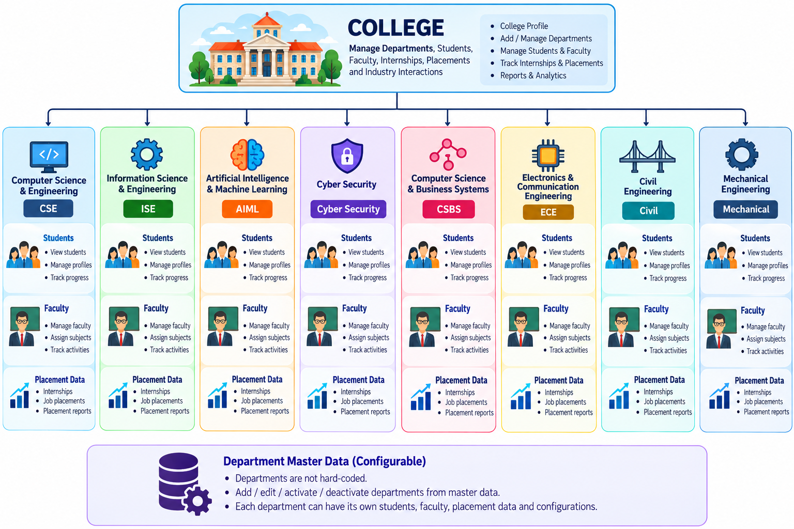

7. Student Management Module
This is one of the core modules.

Student Registration
Students should be able to register using:
- Name
- Email
- Mobile
- College
- Department
- USN / Student ID
- Admission year
- Graduation year
- Semester
- CGPA
- Backlogs
- Date of birth
- Gender
- Location
- Resume
- Profile photo

Academic Profile
- Degree
- Branch
- Semester
- CGPA
- 10th percentage
- 12th/Diploma percentage
- Backlogs
- Certifications
- Academic projects

8. Student Skill Profile
This is critical because it becomes the foundation of the Skill Matching Engine.
Students should be able to maintain:

Technical Skills
Example:
Programming
├── Python
├── Java
├── C
├── C++
└── JavaScript

Web Development
├── React
├── Node.js
├── Django
└── REST API

AI/ML
├── Machine Learning
├── Deep Learning
├── NLP
├── Computer Vision
└── Generative AI

Database
├── MySQL
├── PostgreSQL
├── MongoDB
└── SQL

Skill Level
Each skill can have:
- Beginner
- Intermediate
- Advanced
- Expert
The system should preferably also maintain evidence for a skill:
- Certification
- Project
- Internship
- Assessment score
- Training completed
- GitHub/project link
This prevents the system from depending only on self-declared skills.

9. Student Resume/Profile Module
Students should have a complete digital career profile.
Student Profile
│
├── Personal Information
├── Academic Information
├── Skills
├── Certifications
├── Projects
├── Internships
├── Experience
├── Achievements
├── Resume
├── GitHub
├── LinkedIn
└── Portfolio
The platform should eventually be able to generate a standardized resume from this information.

10. Internship Management Module
Companies can create internship opportunities.

Internship Creation
Company specifies:
- Internship title
- Description
- Internship type
- Mode – Online/Offline/Hybrid
- Location
- Duration
- Start date
- End date
- Stipend
- Number of positions
- Required degree
- Required departments
- Minimum CGPA
- Maximum backlogs
- Graduation year
- Required skills
- Preferred skills
- Selection process
- Application deadline
Example:
AI/ML Intern

Required Skills:
Python → Intermediate
Machine Learning → Intermediate
SQL → Basic
React → Basic

Eligibility:
CGPA ≥ 7.0
No active backlogs
CSE / ISE / AIML
2027 Graduating Batch

11. Internship Application Module
Students can:
- Search internships
- Filter internships
- View eligibility
- Apply
- Withdraw application
- Track application status
- Receive notifications
- Attend selection rounds
- View results

Application Status

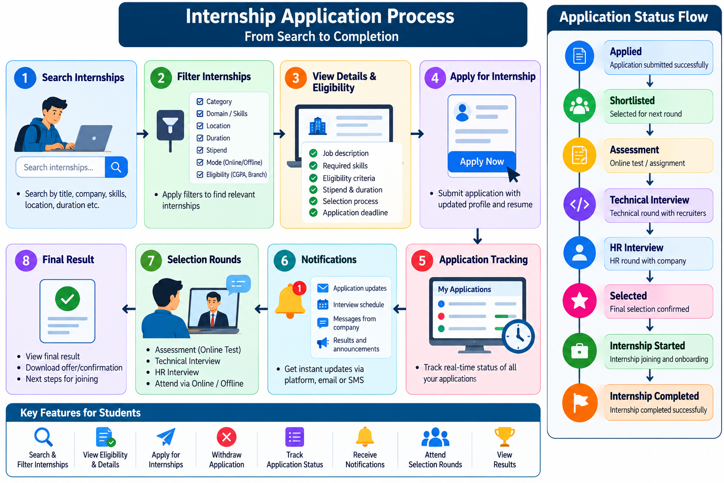
Possible status values:
- Applied
- Under Review
- Shortlisted
- Rejected
- Assessment
- Interview
- Selected
- Joined
- Completed
- Withdrawn

12. Placement / Job Management Module
Companies can publish jobs.

Job Posting
Company specifies:
- Job title
- Job description
- Job location
- Work mode
- Salary package
- Employment type
- Department
- Graduation year
- Minimum CGPA
- Backlog criteria
- Required skills
- Preferred skills
- Experience
- Application deadline
- Number of positions
- Selection process
Example:
Software Engineer

Eligibility:
CSE / ISE / AIML
CGPA ≥ 7.0
No active backlogs

Required:
Java
SQL
React
DSA

Preferred:
Spring Boot
AWS
Git

13. Direct Hiring Companies
The system should support companies that directly recruit students without offering internships.
Company types should therefore be configurable.
Company Type

1. Internship Provider
2. Internship + Placement
3. Direct Hiring
4. Skill Enhancement Provider
5. Training + Hiring
6. Consulting / Industry Partner
A company may also belong to multiple categories.

14. Internship-to-Placement Conversion
This is an important differentiator.
For companies offering internships followed by employment:
Student
│
▼
Internship
│
▼
Performance Evaluation
│
├── Not Eligible
│
└── Eligible
│
▼
PPO / Job Offer
│
▼
Placement
The company can track:
- Internship attendance
- Performance
- Mentor feedback
- Project completion
- Skill improvement
- Final evaluation
- PPO recommendation

15. Skill Matching Engine
This should be treated as the central intelligence module of the platform.
The objective is simple:
Given a student and an internship/job requirement, determine how well the student's profile matches the requirement.

Input
Student:
Python Intermediate
React Intermediate
SQL Basic
Machine Learning Intermediate
CGPA 8.1
Backlogs 0
Branch CSE
Graduation 2027
Company requirement:
Python Intermediate
React Intermediate
SQL Intermediate
Machine Learning Basic
CGPA 7.0
Backlogs 0
Branch CSE / ISE / AIML
Graduation 2027

Matching Result
Eligibility: YES

Overall Match: 87%

Python ✓
React ✓
SQL △ Skill Gap
Machine Learning ✓
CGPA ✓
Backlogs ✓
Department ✓
Graduation Year ✓

16. Skill Matching Algorithm
Initially, the team can implement a rule-based weighted matching engine.
Example:
Parameter | Weight
Required Skills | 40%
Academic Eligibility | 20%
Department | 10%
Graduation Year | 10%
Certifications | 5%
Projects | 5%
Experience/Internship | 5%
Assessment | 5%
Overall score:
Match Score =
Skill Score
+ Academic Score
+ Department Score
+ Graduation Score
+ Certification Score
+ Project Score
+ Experience Score
+ Assessment Score
Later, this can be upgraded to an AI/ML-based recommendation engine.

17. Skill Gap Analysis
Instead of simply saying Eligible / Not Eligible, the system should explain the reason.
Example:
Student: Rahul

Target Role:
Full Stack Developer

Match Score: 72%

Strong Skills
✓ JavaScript
✓ React
✓ HTML/CSS
✓ Git

Skill Gaps
⚠ Node.js
⚠ MongoDB
⚠ REST API
⚠ Docker

Recommendation:
Complete:
1. Node.js Training
2. MongoDB Training
3. REST API Project

Potential Match After Training:
91%
This makes the system much more useful than a normal placement portal.

18. Skill Enhancement Module
Companies or training organizations can publish skill development programs.
Examples:
- Python Full Stack
- React Development
- AI/ML
- Data Science
- Cybersecurity
- Cloud Computing
- DevOps
- IoT
- Communication Skills
- Aptitude
- Interview Preparation
The system can recommend these programs based on identified skill gaps.
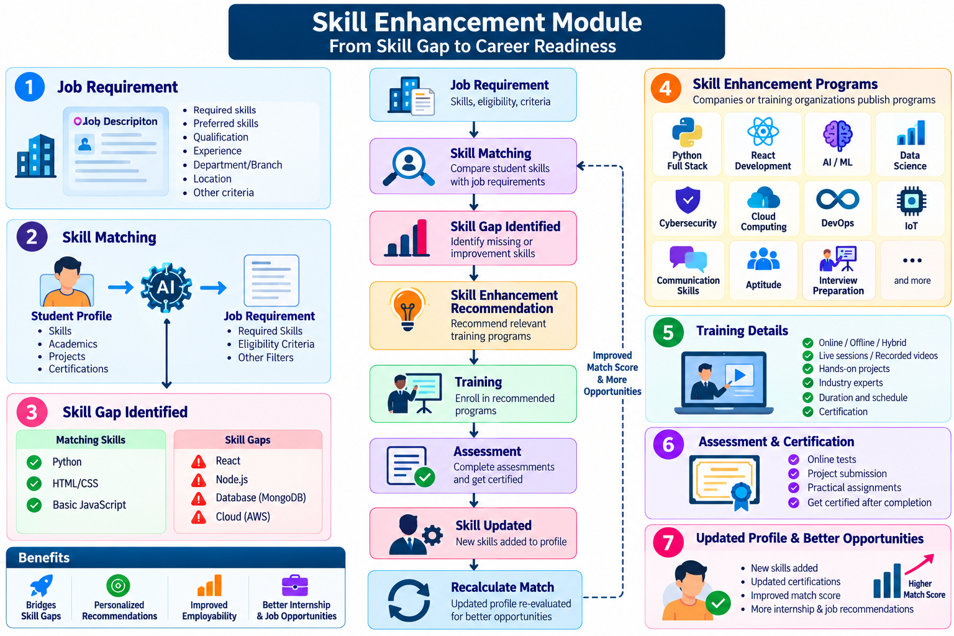

19. Company Dashboard
Companies should have a separate dashboard.

Dashboard KPIs
Active Internships 12
Active Jobs 8
Applications 542
Shortlisted 108
Interviews 65
Selected 27
Internship Conversions 12

Company Features
- Company profile
- Create internship
- Create job
- Manage applications
- View matched students
- Shortlist candidates
- Schedule interviews
- Conduct assessments
- Update selection status
- Provide feedback
- Track interns
- Convert interns to employees
- Download candidate resumes
- Communication/notifications

20. College Dashboard
College administrators should see:

College KPIs
Total Students 2,850
Registered Students 2,620
Active Internships 86
Job Opportunities 64
Students Placed 1,420
Students Internships 1,890
Placement Percentage 54%
Average Package ₹7.2 LPA
Highest Package ₹24 LPA

Department-wise Analysis
CSE 72% Placement
ISE 68%
AIML 75%
Cyber Security 61%
ECE 48%
Mechanical 42%
Civil 36%

21. Student Dashboard
The student dashboard should be simple and career-oriented.

Dashboard
Welcome, Student

Profile Completion 86%
Skill Match Score 78%

Recommended Internships 8
Recommended Jobs 5
Applications 12
Shortlisted 3
Interviews 2

Skill Gaps 4
Recommended Courses 3

Quick Actions
- Complete Profile
- Update Skills
- Upload Resume
- Find Internship
- Find Jobs
- View Recommendations
- View Applications
- Skill Gap Analysis

22. Skill Provider Dashboard
Skill enhancement companies should have their own dashboard.
They can:
- Create training programs
- Define skills covered
- Define prerequisites
- Define duration
- Set fees/free programs
- Conduct assessments
- Issue certificates
- Track enrolled students
- Report completion
The system can connect:
Company Requirement
↓
Skill Gap
↓
Skill Provider
↓
Training
↓
Assessment
↓
Certificate
↓
Improved Student Profile

23. Notification Module
Central notification system should support:
- Email
- In-app notifications
- SMS/WhatsApp integration as future enhancement
Notifications for:

Students
- New matching internship
- New matching job
- Application shortlisted
- Interview scheduled
- Application rejected
- Skill gap identified
- Training recommendation
- Selection confirmation

Companies
- New application
- New eligible student
- Interview reminder
- Application deadline

College
- New company registration
- New opportunity
- Student selection
- Internship completion
- Placement statistics

24. Search & Filter Module
Search should be available throughout the system.

Students can search
- Companies
- Jobs
- Internships
- Skill programs

Companies can search
- Students
- Skills
- Departments
- Colleges
- CGPA
- Graduation year
- Certifications

College can search
- Companies
- Opportunities
- Students
- Placement records

25. Reports & Analytics Module
The system should generate reports for colleges and administrators.

Student Reports
- Internship applications
- Job applications
- Selection status
- Skill profile
- Skill gaps

College Reports
- Department-wise placement
- Company-wise placement
- Internship statistics
- Placement package statistics
- Internship-to-job conversion
- Skill distribution

Company Reports
- Applications
- Shortlisting
- Selection ratio
- Department-wise applicants
- Internship performance
- PPO conversion

26. Important Database Entities
A relational database such as PostgreSQL/MySQL would be appropriate.
Core entities:
Users
Roles
Permissions
Colleges
Departments
Students
Faculty
Companies
CompanyTypes
Recruiters
Skills
StudentSkills
SkillLevels
Certifications
Projects
Resumes
Internships
Jobs
Applications
InterviewRounds
Assessments
Selections
InternshipEvaluations
JobOffers
SkillPrograms
Enrollments
SkillGaps
SkillMatches
Notifications
Messages
Reports
AuditLogs

27. Simplified Database Relationship
USERS
│
┌───────┴────────┐
│ │
STUDENTS STAFF
│ │
▼ ▼
DEPARTMENT COLLEGE
│ │
└───────┬────────┘
│
▼
COLLEGE
│
│
COMPANY ──────── JOB / INTERNSHIP
│ │
│ ▼
│ APPLICATION
│ │
│ ▼
│ STUDENT
│ │
└──────────────┐ │
▼ ▼
SKILLS
│
▼
SKILL MATCHING
│
┌───────┴────────┐
▼ ▼
ELIGIBLE SKILL GAP
│ │
▼ ▼
APPLICATION TRAINING
│
▼
SKILL UPDATE

28. Recommended Backend Architecture
Since the frontend is React, I would recommend keeping the architecture API-based.
React Frontend
│
▼
API Gateway
│
┌─────────┴─────────┐
│ │
Authentication Business APIs
│ │
└─────────┬─────────┘
│
Backend Application
│
┌────────────────┼────────────────┐
│ │ │
▼ ▼ ▼
User Management Opportunity Skill Engine
Management
│ │ │
└────────────────┼────────────────┘
│
▼
Database
│
┌───────────┼───────────┐
▼ ▼ ▼
Storage Email Notifications
A practical stack could be:

Frontend
- React
- React Router
- Axios
- Tailwind CSS / Material UI
- React Hook Form
- Recharts / Chart.js

Backend
One suitable option:
- Node.js
- Express.js
- REST APIs
- JWT Authentication

Database
- PostgreSQL

File Storage
- AWS S3 / Cloudinary / equivalent

Deployment
- React → Vercel/Netlify or cloud hosting
- Backend → AWS/Azure/Render/etc.
- PostgreSQL → Managed PostgreSQL

29. React Frontend Structure
The frontend should be organized according to modules rather than putting everything into one large application.
src/

├── components/
├── layouts/
├── pages/
│
├── auth/
│ ├── Login
│ ├── Register
│ ├── ForgotPassword
│
├── student/
│ ├── Dashboard
│ ├── Profile
│ ├── Skills
│ ├── Resume
│ ├── Internships
│ ├── Jobs
│ ├── Applications
│ ├── SkillMatch
│ └── Recommendations
│
├── college/
│ ├── Dashboard
│ ├── Students
│ ├── Departments
│ ├── Internships
│ ├── Placements
│ └── Reports
│
├── company/
│ ├── Dashboard
│ ├── Profile
│ ├── Internships
│ ├── Jobs
│ ├── Candidates
│ └── Recruitment
│
├── admin/
│ ├── Dashboard
│ ├── Users
│ ├── Colleges
│ ├── Companies
│ ├── Skills
│ └── Reports
│
└── services/
├── authService
├── studentService
├── collegeService
├── companyService
├── internshipService
├── jobService
└── skillMatchService

30. Role-Based Permission Architecture
Don't simply hide menus in React. Permissions must also be enforced at the backend/API level.
Example:
ROLE CREATE JOB VIEW STUDENTS APPROVE COMPANY
--------------------------------------------------------------------
Super Admin ✓ ✓ ✓
College Admin ✗ ✓ ✗
Company Admin ✓ Limited ✗
Recruiter ✓ ✓ ✗
Student ✗ Own Profile ✗
The system should support permissions such as:
STUDENT_VIEW
STUDENT_EDIT
COMPANY_VIEW
COMPANY_EDIT
INTERNSHIP_CREATE
INTERNSHIP_APPROVE
JOB_CREATE
JOB_APPROVE
APPLICATION_VIEW
APPLICATION_UPDATE
SKILL_CREATE
SKILL_MATCH
REPORT_VIEW
USER_MANAGE
This makes the application scalable.

31. Complete Opportunity-to-Placement Flow
This is probably the most important business process.
COMPANY
│
▼
Creates Job/Internship
│
▼
Defines Eligibility
│
▼
Skill Requirements
│
▼
┌───────────────────┐
│ SKILL MATCHING │
│ ENGINE │
└─────────┬─────────┘
│
┌───────┴────────┐
▼ ▼
Eligible Not Eligible
│ │
▼ ▼
Recommend Student Identify Skill Gap
│ │
▼ ▼
Apply Job Training Recommendation
│ │
▼ ▼
Shortlisting Skill Training
│ │
▼ ▼
Assessment Re-Matching
│
▼
Interview
│
▼
Selection
│
▼
Job / Internship
│
▼
Final Outcome

32. Future AI Enhancement
The first version should not overcomplicate the project with AI.
Build the rule-based matching engine first.
Later, AI can be introduced for:

Resume Parsing
Upload:
Resume.pdf
System extracts:
Python
React
Django
SQL
Machine Learning
and updates the student's skill profile.

JD Parsing
Company uploads:
Job_Description.pdf
System extracts:
Required Skills
Qualification
Experience
Location
Salary
Eligibility

AI Recommendation
Eventually:
Student Profile
+
Resume
+
Projects
+
Certifications
+
Assessment
+
Job Description
↓
AI Matching
↓
Match Score + Explanation

33. Security Requirements
The application will contain sensitive student and company information, so security should be considered from the beginning.
Required:
- Password hashing
- JWT/session security
- Role-based authorization
- API authorization
- Input validation
- File upload validation
- SQL injection protection
- XSS protection
- CSRF protection where applicable
- Rate limiting
- Secure password reset
- Audit logs
- Account lock/disable mechanism
- HTTPS
- Database backup
- Data access restrictions

34. MVP Development Plan
I recommend not developing everything simultaneously.

Phase 1 – Foundation
Authentication
+
User Management
+
Roles & Permissions
+
College Management
+
Department Management

Phase 2 – Student
Student Registration
Student Profile
Academic Profile
Skills
Certifications
Projects
Resume

Phase 3 – Company
Company Registration
Company Verification
Company Profile
Recruiter Management

Phase 4 – Opportunities
Internship Management
Job Management
Eligibility Criteria
Applications
Shortlisting

Phase 5 – Skill Matching
Skill Master
Student Skill Profile
Job Requirements
Skill Matching Engine
Match Score
Skill Gap Analysis
Recommendations

Phase 6 – Recruitment
Assessment
Interview
Selection
Offer
Internship Tracking
Internship Evaluation
PPO
Placement

Phase 7 – Analytics
Student Dashboard
College Dashboard
Company Dashboard
Admin Dashboard
Reports
Analytics

Phase 8 – AI Enhancement
Resume Parsing
JD Parsing
AI Skill Extraction
AI Recommendation
Predictive Skill Gap
Career Recommendation

35. Key Dashboards
The final application should have at least these dashboards:
PLATFORM
│
┌─────────┼─────────┐
│ │ │
▼ ▼ ▼
ADMIN COLLEGE COMPANY
│ │ │
│ │ │
└─────────┼─────────┘
│
▼
STUDENT
│
▼
SKILL ENGINE

Super Admin Dashboard
Platform-wide statistics.

College Dashboard
Department, internship and placement statistics.

Department Dashboard
Student skills, opportunities and placements.

Company Dashboard
Recruitment pipeline and candidates.

Student Dashboard
Career opportunities and skill development.

Skill Provider Dashboard
Training and skill enhancement.

36. Important Design Principle
The platform should not be designed as just another job portal.
The central concept should be:
Student → Skills → Opportunities → Matching → Skill Gap → Training → Internship → Evaluation → Placement
That complete lifecycle is what differentiates the proposed platform.

37. Suggested Navigation

Student
Dashboard
My Profile
Academic Profile
My Skills
Projects
Certifications
Resume
Internships
Jobs
Recommended for You
Skill Match
Skill Gaps
Training Programs
Applications
Interviews
Offers
Notifications

College
Dashboard
College Profile
Departments
Students
Faculty
Internships
Jobs
Companies
Applications
Placements
Internship Tracking
Skill Analytics
Reports
Notifications

Company
Dashboard
Company Profile
Recruiters
Internships
Jobs
Matched Students
Applications
Shortlisted
Interviews
Selected Candidates
Internship Tracking
PPO / Offers
Reports

Super Admin
Dashboard
Users
Colleges
Companies
Departments
Students
Skills
Internships
Jobs
Applications
Skill Matching
Training Providers
Reports
Roles & Permissions
Notifications
Audit Logs
System Settings

38. Final Developer Perspective
The development team should think of this as four connected systems:
┌───────────────────────────────────────────────┐
│ ACADEMIA–INDUSTRY COLLABORATION │
├───────────────────────────────────────────────┤
│ │
│ 1. ACADEMIA MANAGEMENT │
│ College → Department → Students │
│ │
│ 2. INDUSTRY MANAGEMENT │
│ Company → Internship → Jobs │
│ │
│ 3. CAREER MANAGEMENT │
│ Student → Application → Interview → Job │
│ │
│ 4. INTELLIGENCE LAYER │
│ Skills → Matching → Skill Gap → Training │
│ │
└───────────────────────────────────────────────┘

